**Score Management System Document Design**

|  |  |  |  |  |
| --- | --- | --- | --- | --- |
| Version | Date | Author | Edit Record | Remark |
| 1.0 | 2023/1/9 | Dylan | New |  |
|  |  |  |  |  |

1 Production Introduce

In order to make our school teacher work effectively, this system would help our teacher have a quick look at student’s score and get some statistic result.

2 System Design Overview

The worker would click button on app, and then request will enter into java program, java api will call MySQL service to get score data and return back to caller after processing.

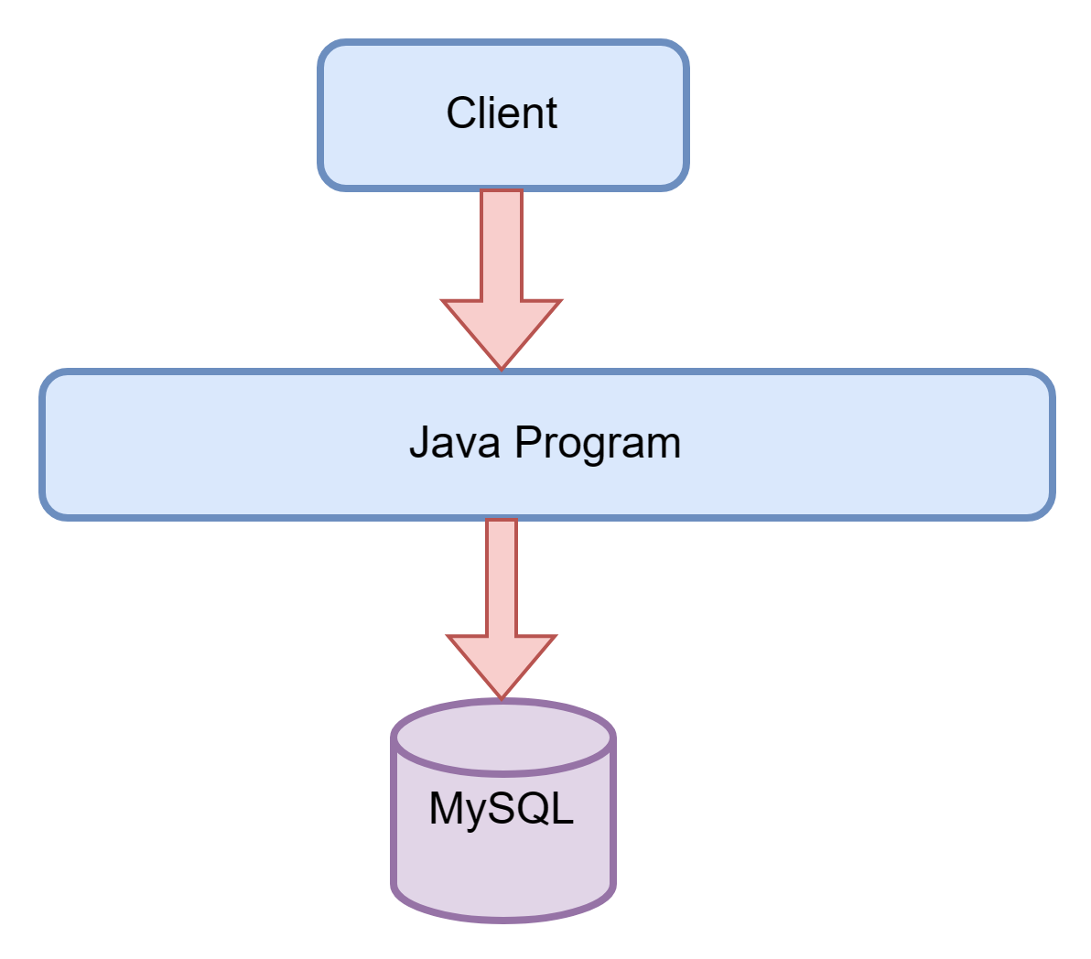

3 Table and Field

1. Score

|  |  |  |  |  |
| --- | --- | --- | --- | --- |
| field | description | type | default | Is null |
| id | Primary key | int |  | no |
| cid | class id | int | 0 | no |
| sid | subject id | Int | 0 | no |
| score | score | Int | 0 |  |

4 ER

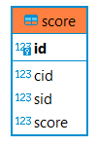

5 Business Process Diagram

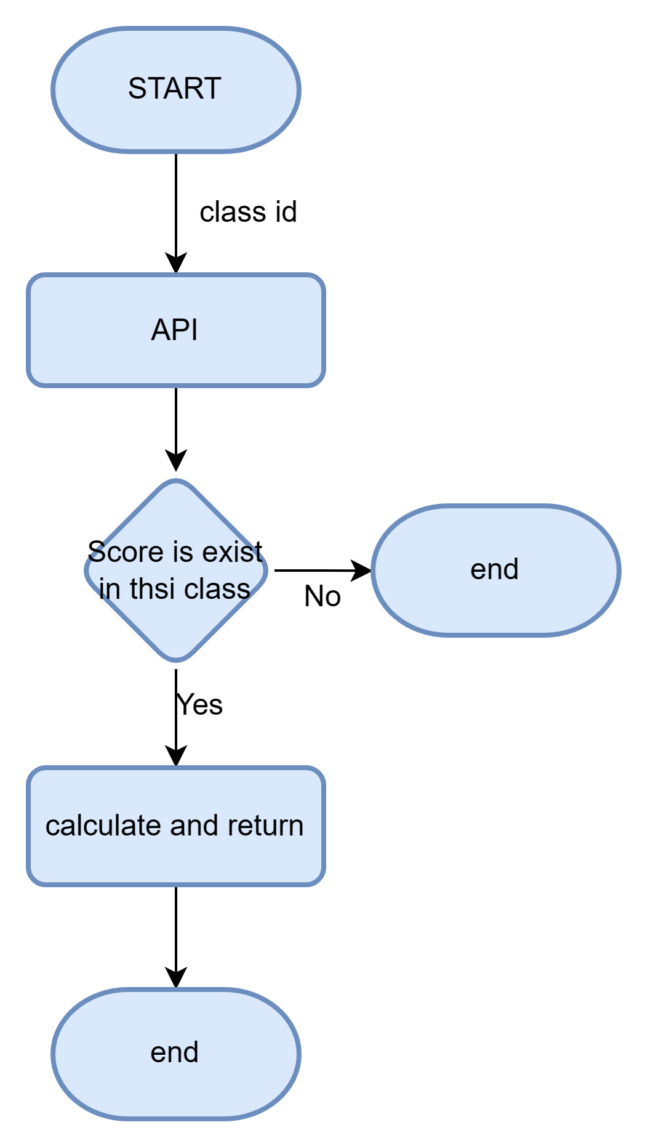

6 API Design

|  |  |  |  |
| --- | --- | --- | --- |
| Method | /statistic | | |
| Description | Get avg and median data | | |
| Type | Post | | |
| Parameter Style | param | | |
| Field name | Description | Necessary | Type |
| cid | Class id | Y | int |
| response |  | | |
| {    "code": 1,      "msg": **null**,      "data": {          "cid": 1,          "sid": 2,          "midian": "87.00",          "avg": "88.67"      }  } | | | |